**Research Proposal**

**Analyzing the Influence of Driving Habits on Fuel Efficiency**

Raviteja Bandarupalli

001608348

**Abstract:**

This project uses the mtcars dataset in RStudio to investigate how different driving behaviours affect fuel efficiency. Finding relationships between driving habits and miles per gallon (mpg) allows for the optimisation of fuel use. To determine how various factors affect fuel efficiency, the study looks at average speed, acceleration patterns, and engine displacement. By conducting a thorough analysis, this research advances our knowledge of how routine driving behaviours impact a car's fuel efficiency and offers useful advice to manufacturers and consumers alike on how to reduce environmental impact and increase energy efficiency.

**Research Objectives:**

The goal of the research is to understand the complex relationship that exists between fuel consumption and daily driving behaviours. Through an examination of the mtcars dataset, the research aims to pinpoint critical elements, such as average speed, acceleration trends, and engine displacement, that have a substantial impact on fuel efficiency. By means of meticulous examination, the study aims to offer discernments that can guide tactics to maximise fuel usage, consequently augmenting transportation's energy efficiency and mitigating its ecological footprint.

The project also seeks to close the knowledge gap between empirical data and practical insights that manufacturers and consumers can use. The study intends to provide people with the information necessary to make educated decisions about the use and upkeep of their vehicles by clarifying how driving behaviours affect fuel efficiency. Furthermore, the results may serve as a guide for automakers as they design vehicles with higher fuel efficiency and create cutting-edge technologies to advance sustainability in the automotive sector.

**Hypotheses:**

1. Higher average speeds are positively correlated with lower fuel efficiency (mpg) in the mtcars dataset, indicating that faster driving habits lead to reduced fuel efficiency due to increased energy consumption.
2. Erratic acceleration patterns are negatively associated with fuel efficiency (mpg) in the mtcars dataset, suggesting that smoother acceleration leads to better fuel efficiency by minimizing energy waste.
3. Higher engine displacement is inversely related to fuel efficiency (mpg) in the mtcars dataset, indicating that vehicles with larger engine displacements exhibit lower fuel efficiency due to increased weight and power requirements.

**About the Dataset:**

The mtcars dataset is a well-known dataset in R that contains measurements on 11 different attributes for 32 different cars. It includes various car characteristics such as miles per gallon (mpg), number of cylinders (cyl), engine displacement (disp), gross horsepower (hp), rear axle ratio (drat), weight (wt), quarter-mile time (qsec), engine type (vs), transmission type (am), number of forward gears (gear), and number of carburetors (carb). This dataset is commonly used for exploratory data analysis (EDA), regression analysis, and predictive modeling tasks in data science and statistics.

Dependent Variables :

These are the variables that might change in response to the independent variables.

1. **mpg**: Miles per gallon, representing fuel efficiency

Independent Variables:

These are the variables that are not changed by other variables in the dataset.

1. **cyl**: Number of cylinders in the engine.
2. **disp**: Engine displacement (in cubic inches).
3. **hp**: Gross horsepower.
4. **drat**: Rear axle ratio.
5. **wt**: Weight (in 1000 lbs) of the car.
6. **qsec**: Quarter-mile time (in seconds) for a car to accelerate from rest.
7. **vs**: Engine type - 0 (V-shaped) or 1 (straight).
8. **am**: Transmission type - 0 (automatic) or 1 (manual).
9. **gear**: Number of forward gears.
10. **carb**: Number of carburetors

**Expected Outcomes:**

Determining which driving habits, such as transmission type (automatic vs. manual), affect fuel efficiency the most. Assessing the magnitude of the effect of driving habits on fuel efficiency, providing insights into how much fuel efficiency varies based on different driving behaviors. Developing models that can predict fuel efficiency based on driving habits, allowing for the estimation of fuel consumption under various scenarios. Providing recommendations for optimizing driving behaviors to enhance fuel efficiency, potentially leading to reduced fuel consumption and environmental impact.

**DAG code:**

library(ggdag)

library(ggplot2)

our_mtcars_dag <- dagify(

mileage ~ weight + hp, # Miles per gallon is influenced by car weight and horsepower

weight ~ qsec, # Car weight is influenced by quarter mile time

horsepower ~ cylinder, # Horsepower is influenced by number of cylinders

qsec ~ displacement, # Quarter mile time is influenced by displacement

cylinder ~ displacement, # Number of cylinders is influenced by displacement

displacement ~ vs + am # Displacement influences engine type (vs) and transmission (am)

)

ggdag(our_mtcars_dag) +

theme_minimal() +

theme(plot.background = element_rect(fill = "lightblue"))

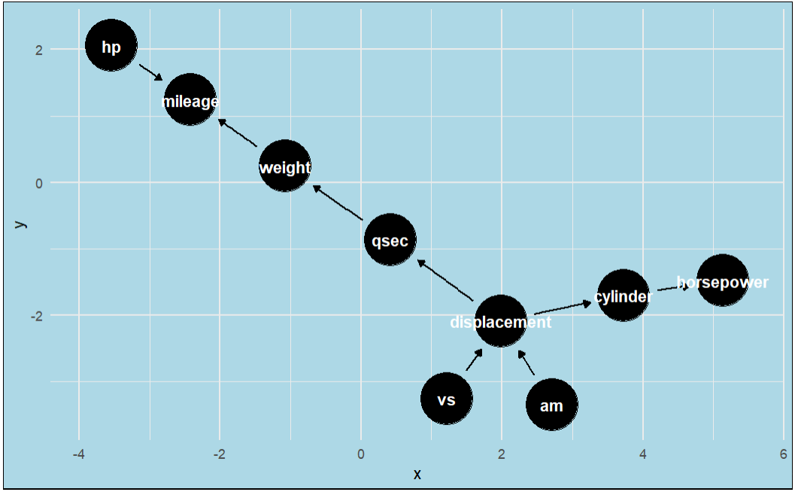

The "mtcars" dataset's Directed Acyclic Graph (DAG) illustrates the assumed causal relationships between variables through a visual representation of how characteristics such as engine type, horsepower, and car weight affect fuel efficiency. This graphical model makes it easier to understand the intricate relationships that exist within automotive performance by providing a clear summary of how changes in one variable may affect others.

**Literature Review:**

Driving behavior significantly influences fuel efficiency [1]. Studies explore this relationship using machine learning algorithms and driving volatility measures [1][3]. Research indicates a correlation between energy-efficient driving behaviors and reduced fuel consumption [2]. Drive-cycle simulations and naturalistic driving data are used to assess driving behavior's impact on fuel efficiency [5]. Understanding driving parameters related to fuel economy is crucial for promoting efficient driving practices.

Efficient driving behavior has been extensively studied for its impact on fuel consumption. Research indicates that adopting energy-efficient driving practices can lead to significant reductions in fuel consumption . Studies have shown that more efficient driving behavior can result in nearly a 7% reduction in fuel consumption. However, achieving energy-efficient driving can be challenging due to ingrained driving habits that may not align with energy-saving rules [2]. This highlights the importance of understanding the relationship between driving behavior and fuel efficiency to develop effective strategies for promoting eco-friendly driving practices.

Moreover, investigations into driver behavior and its correlation with fuel consumption have revealed intriguing findings. Studies suggest that there exists a correlation between attention horizon, a metric representing the overall driver behavior, and fuel consumption. Sensible driving, characterized by smooth acceleration, maintaining steady speeds, and minimizing aggressive maneuvers, has been shown to save more gas than commonly perceived. This underscores the importance of providing eco-driving training to drivers, as such training has demonstrated notable reductions in both city and highway fuel consumption.

**References:**

[1]. Mohammadnazar, A., Khattak, Z. H., & Khattak, A. J. (2024). Assessing driving behavior influence on fuel efficiency using machine-learning and drive-cycle simulations. Transportation Research Part D: Transport and Environment, 126, 104025. <https://doi.org/10.1016/j.trd.2023.104025>

[2]. Ma, Z., Jørgensen, B. N., & Ma, Z. (2024). A scoping review of energy-efficient driving behaviors and applied state-of-the-art AI methods. Energies, 17(2), 500. <https://doi.org/10.3390/en17020500>

[3]. Ping, P., Qin, W., Xu, Y., Miyajima, C., & Takeda, K. (2019). Impact of driver behavior on fuel consumption: Classification, Evaluation and prediction using Machine Learning. IEEE Access, 7, 78515–78532. <https://doi.org/10.1109/access.2019.2920489>